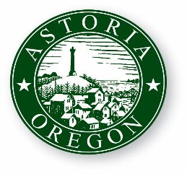CITY OF ASTORIA

Founded 1811 ● Incorporated 1856

**ASTORIA CITY COUNCIL VISION AND GOALS**

**FISCAL YEAR 2021-2023 (Revised May 2022)**

**Astoria City Council Vision**

**The Astoria City Council’s actions and decisions value:**

* **Preservation of Astoria’s unique character;**
* **Livability and quality of life for residents;**
* **A thriving local economy;**
* **Resilience as a community.**

**City government will provide high quality service, be responsive, and be transparent. The City of Astoria is committed to being a community welcoming diversity, embracing equity and inclusion, and where all are accepted, valued, respected, and safe.**

**Astoria City Council Goals**

# **Support efforts to increase the housing supply using the County Housing Study as a guide. The City will focus on workforce and affordable housing overall and changes to code to facilitate greater density and missing middle housing. Council will support the efforts of NW Oregon Housing Authority and Clatsop County to locate workforce and affordable housing within the City Limits.**

# **Ensure long-term infrastructure sustainability through future infrastructure funding on needed water, sanitary sewer, storm sewer, road and bridge upgrades, as well as continuing high quality watershed management.**

# **Advance the Library Remodel project by either a bond measure if public support is indicated, or Phase 1 remodel using existing funds.**

# **Support work and recommendations of the Homelessness Solutions Taskforce (HOST) as well as other community efforts to address homelessness. Implement revised ordinances to enhance community quality of life and explore housing opportunities with Clatsop County.**

# **Work with community partners to implement the five-year economic development strategy. Coordinate with Clatsop Economic Development Resources (CEDR), Astoria Warrenton Chamber of Commerce, State of Oregon Regional Solutions Team, and other economic development entities on post COVID-19 pandemic recovery.**

# **Enhance public safety, through quality of life, community outreach, community involvement, and community policing.**

# **Increase disaster resilience and awareness among the community, City staff, and facilities.**